**Assignment-2**

**1. Who is the customer who spent the most on rental movies? Return his/her customer id, first**

**name and the amount spent.**

**SQL Used :**

**select customer.customer_id,customer.first_name,payment.amount from customer,payment where customer.customer_id=payment.customer_id and amount in (select max(amount) from payment);**

**Output:**

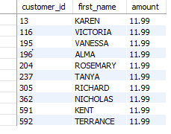

**Screenshot:**

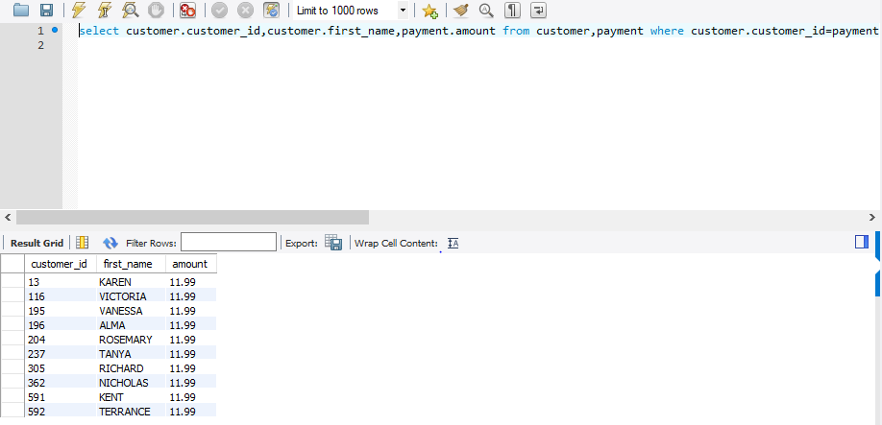

**2. Give an interesting query of your own that is not already in the assignment. The query should**

**involve at least two joins, HAVING clause and aggregation operation. Give the English explana-**

**tion and the answer.**